**Synaesthesia**

Polina Dimova (Oberlin College)

Synaesthesia is the confusion or conflation of sensory modalities, where one sense is experienced or described in terms of another as in Charles Baudelaire’s simile ‘perfumes sweet as oboes, green as prairies.’ Synaesthesia captures an already existing tendency in language to blend the senses as in ‘sweet melody,’ ‘velvety voice,’ or ‘loud colors,’ and psychologists have conducted studies that show our shared experience of weak audio-visual associations between low pitch and darker colors, or high pitch and lighter colors. In a strictly neurological sense, synaesthesia is a perceptual condition in which the stimulation of one sensory system (e.g., hearing), triggers sensations in another sensory system (e.g., vision). Cross-sensory associations form one-to-one correspondences that are stable, delicately nuanced, and highly individual. For instance, a synaesthete may experience the timbre of violins as lime green, or the pitch A as burgundy. Synaesthetic associations occur as involuntary, automatic, and emotional responses to sensory stimuli. They persist throughout life and often aid memory: some synaesthetes reliably remember historical dates thanks to their color-to-number associations. The prevalence of synaesthesia has been contested over time, with varying ratios of synaesthetes to non-synaesthetes of 1 in 2000, 1 in 100 for colored letters and numbers in recent studies, and even 1 in 23 for all types of synaesthesia.

The fascination with synaesthesia in Modernism began with the publication of two seminal poems: Charles Baudelaire’s ‘Correspondences’ from *Les Fleurs du Mal* (*Flowers of Evil*) (1857) and Arthur Rimbaud’s ‘Vowels’ (1871). Whereas Baudelaire’s Symbolist sonnet suggested the universality of synaesthetic experience, Rimbaud’s poem reveled in the highly individualistic correspondences between graphemes and colors: ‘Black A, white E, red I, green U, blue O.’ Baudelaire’s ‘Correspondences’ offers two interpretations of synaesthesia: first, the mixing of the senses allows humanity to transcend the fragmentation of the material world and reach spiritual unity, as ‘perfumes, colors, and sounds correspond.’ Second, in the sestet of the sonnet, the confusion of the senses results in the decadent disintegration of symbolic meaning. Likewise, Joris-Karl Huysmans’s decadent novel *A Rebours* (*Against Nature*) (1884) conflates colors, sounds, tastes, and fragrances by indulging in nuanced sensory experiences rather than searching for meaning. Huysmans’s anti-hero Des Esseintes experiments with a mouth organ where the taste of each liqueur recreates the sensation of a specific symphonic instrument. For instance, the character savors the music of the violin and the viola, which he hears on his palate in the flavors of old brandy and rum.

Modernist synaesthesia responded to Aristotle’s notion of the common sense, believed to integrate our five senses into unified experiences, and was prefigured by the Romantic melding of poetry and music. The heyday of artistic synaesthesia coincided with the *fin de siècle* surge in its scientific study as a psycho-physiological phenomenon, leading to the 1890 International Congress on Color Hearing in Paris. While over two hundred scientific articles on the subject were published at the time, by the 1930s the psychoanalytic explorations of the unconscious were eclipsed by Behaviorism (Cytowic), and synaesthesia was largely forgotten or dismissed as a post-Romantic fad.

Synaesthesia sparked the creativity of Modernist artists by engaging with heterogeneous and conflicting cultural and scientific discourses. In *Degeneration* (1892), Max Nordau infamously denounced synaesthesia as a symptom of mental disturbance, a sort of relapse into the state of a mollusk. Inspired by Newton’s analogies between sound and light waves, the inventor Alexander Wallace Rimington patented in 1893 the best-known color-organ of his time, which projected colorful lights across the spectrum band. Rimington relied on the now discredited *fin-de-siècle* scientific theory of synaesthesia based on the allegedly shared frequencies of sound-and-light vibrations. The Symbolists exalted synaesthesia as creating the mystical reality of Baudelaire’s ‘Correspondences.’ In ‘Richard Wagner and the Tannhäuser in Paris’ (1861), Baudelaire further appropriated Wagner’s notion of the total artwork, *Gesamtkunstwerk* for synaesthesia, by interpreting it not only as a synthesis of the arts but also as a unity of the senses.

Indeed, according to Wagner’s aesthetic theories, the total artwork affects the audience on a bodily and emotional level, which allows access to sensory knowledge beyond reason. Wagner’s music uses memorable musical motifs, associated with words, images, and gestures to evoke specific impressions, feelings, objects, and individuals. These so-called *leitmotivs* tell the story of the music drama and, in a synaethetic fashion, trigger immediate, involuntary, persistent, emotional, and meaningful sensory responses.

Following the Wagnerian tradition, Oscar Wilde compares his play *Salomé* (1891) to a piece of music in its repetitive phrasings. The heroine blends music, sight, and scent, as she intones while gazing on Jokanaan’s severed head, ‘Thy voice was an incense vessel and when I looked on thee I heard a strange music.’ Thus, *Salomé* interweaves synaesthesia, Wagnerism, and degeneracy, which were also gendered queer at the time, as the sexologist Havelock Ellis compared color hearing to homosexuality in his *Studies in the Psychology of Sex. Sexual* *Inversion* (1897).

Modernist synaesthesia promised to shed light not only on artistic creativity and human psychology, but also on the mystic cosmos. The synaesthetic illustrations for Annie Besant’s theosophical study *Thought-Forms* (1901) show how music and emotions can be visualized as colors and abstract shapes (Fig. 1), thus enabling the emergence of abstract art. Cosmic imagery of sound and light vibrations, universal audio-visual correspondences, and colorful representations of auras pervaded the works of such artists as Wassily Kandinsky and Alexander Scriabin, both of whom claimed to be synaesthetes, as well as Paul Klee, Hilma af Klint, and Frank Kupka.

In Kandinsky’s book ‘Concerning the Spiritual in Art’ (1910) and his multimedia theater piece ‘The Yellow Sound’ (1909), spiritual vibrations of color correspond to the timbres of orchestral instruments: deep blue evokes the cellos, green is the timbre of violins, and yellow conjures the sound of trumpets. Kandinsky believed that synaesthesia manifested itself in highly developed, spiritual individuals fine-tuned to the vibrations of the soul. In his ‘Impression III (Concert)’, Kandinsky captures Arnold Schoenberg’s music that he heard in concert in 1911 (Example. 2). Schoenberg himself experimented with Kandinsky’s color-to-timbre correspondences in his incomplete opera *Die glückliche Hand* (1910-1913).

For his synaesthetic symphony *Prometheus: A Poem of Fire* (1909-1910), Alexander Scriabin conceived of an electric color keyboard (*tastiera per luce*) to illuminate his music. Inspired by Helen Blavatsky’s synaesthetic theory in the theosophical treatise *The Secret Doctrine* (1888) and by Rimington’s color-organ, Scriabin elaborates on the occult relations between colors and sounds by mapping out the color spectrum onto tonalities along the circle of fifths, where C corresponds to red, D to sunny yellow, and F [sharp] to violet-shaded deep blue (Fig. 3.). Yet, *Prometheus* only anticipated Scriabin’s eschatological synaesthetic project *The Mysterium*, which remained incomplete because of the composer’s untimely death in 1915. This grandiose work was to be performed in India and conflate all the arts: music, poetry, light, architecture, dance, and fragrances so as to transfigure the world by unifying the senses.

Inspired by mystical synaesthesia and Wagnerian aesthetics, the Italian Futurists sought to recreate the speed and dynamic totality of everyday life, and stimulated also the lower senses in Futurist cuisine and tactile theater. The artists Giacomo Balla and Carlo Carrà captured the chaos of the modern city with its synaesthetic ‘bubbling and whirling of forms and lights composed of sounds, noises, and smells’ (Carrà, ‘The Painting of Sound, Noise, and Odors,’ 1913). Luigi Russolo studied the vibrations of light and sound in his spectrally colored paintings ‘Music’ (1911) and ‘The Revolt’ (1911), and overturned classical harmony in his noise composition, scored for *intonarumori*, or noisemakers.

Olivier Messiaen, another synaesthetic modernist, described the piano music in the second part of his *Quartet to the End of Time* (1941) as conjuring ‘gentle cascades of blue-orange chords.’ Composed in a German prison-of-war camp, the quartet captures the artist’s synaesthesia augmented by the extreme physical conditions of starvation, cold, and emotional distress. In *Couleurs de la cité celeste* (1963), Messiaen specifically indicated the colors that accompany the modes of limited transpositions developed in his music theories: ‘red, touched with blue,’ ‘orange, gold, and milky white,’ or ‘blue-violet and rose.’

Vladimir Nabokov, the most famous literary synaesthete, endowed many of his characters with the gift of synaesthesia: Cincinnatus in *Invitation to a Beheading*, Fyodor in *The Gift*, and Van in *Ada or Ardor*. In his autobiography *Speak, Memory* (1947), Nabokov reflects on the subtle interaction between colors, sounds, and shapes of letters with the flair of a master stylist: ‘oatmeal *n*, noodle-limp *l*, […] steely *x*, thundercloud *z*, and huckleberry *k*. […] I see *q* as browner than *k*, while *s* is not the light blue of *c*, but a curious mixture of azure and mother-of-pearl.’ Nabokov associated his synaesthesia with both clairvoyance and disjointed hallucinations, while its literary use evokes both aesthetic pleasure and a sense of epiphany.

Since the 1990s, synaesthesia has once again drawn the interest of scientists and critics after fMRI tests confirmed that cross-sensory perception is not a figment of the imagination, but a genuine perceptual condition. Cytowic, Baron-Cohen and Harrrison, and Dann have labored on distinguishing between idiopathic or genuine synaesthesia (Nabokov, Messiaen); pseudo-synaesthesia in synaesthetic metaphors (Scriabin, Baudelaire, Rimbaud); and drug-induced synaesthesia. Dimova has argued that the multifarious discourses of synaesthesia promoted the flourishing transpositions of modernist projects across the arts. Currently active artists with synaesthesia include composer Michael Torke and painter, printmaker, and stage designer David Hockney, famous for creating opera sets informed by his synaesthesia of mingled colors, sounds, shapes, and space.

**Suggested Images**

Fig. 1. Music of Mendelssohn and Music of Gounod. In Annie Besant and C. W. Leadbeater. *Thought-Forms*. Theosophical Publishing House, London, 1901. http://www.gutenberg.org/files/16269/16269-h/16269-h.htm

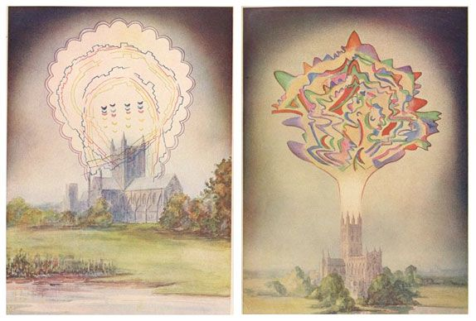

Fig. 2. Wassily Kandinsky, Impression III (Concert), Oil on Canvas, 77.5 x 100 cm. Städtische Galerie im Lenbachhaus, Munich, 1911.

*http://www.wikiart.org/en/wassily-kandinsky/impression-iii-concert-1911*

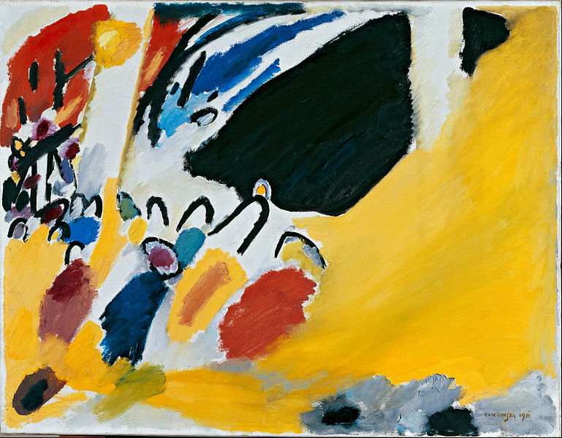

Fig. 3. Scriabin Circle of Fifths: Color and Tonalities. Reproduced from Anna M. Gawboy and Justin Townsend, ‘Scriabin and the Possible.’ MTO 18.2: June 2012. *http://www.mtosmt.org/issues/mto.12.18.2/gawboy_townsend_examples.php?id=9*

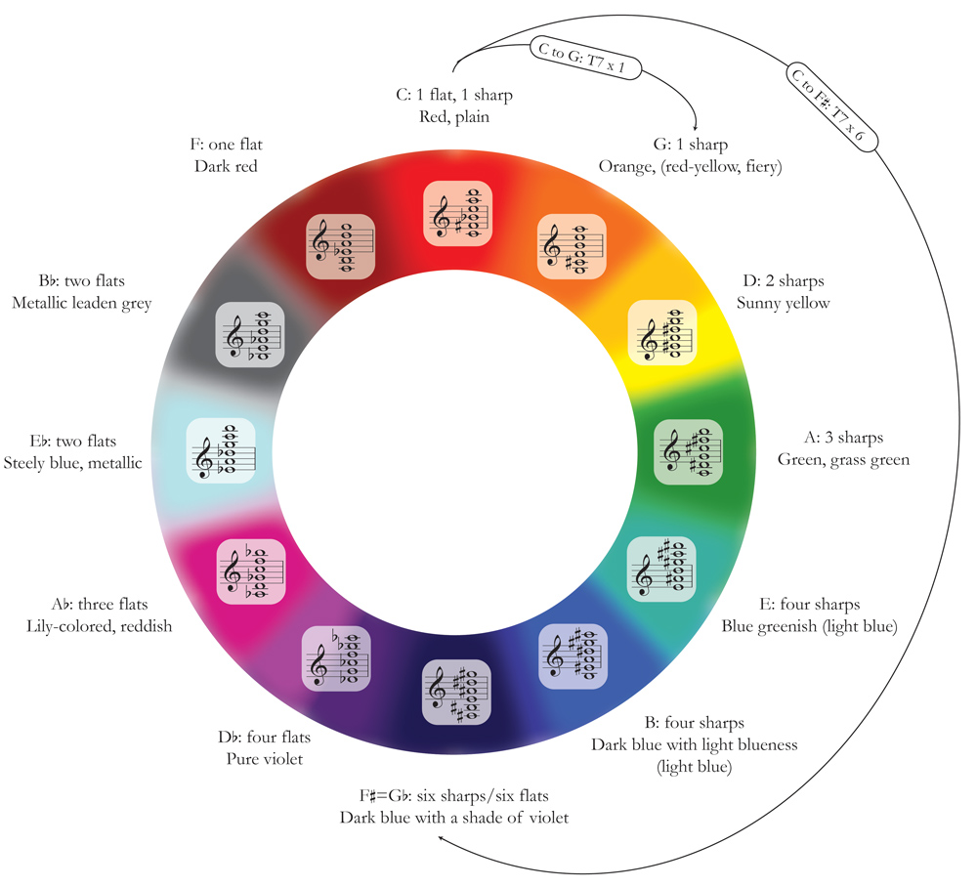

**Suggested Videos**

The 2010 Yale Production of Scriabin’s *Prometheus: A Poem of Fire* with lights. Anna M. Gawboy and Justin Townsend: <https://www.youtube.com/watch?v=V3B7uQ5K0IU>

**Suggested Images**

**I could suggest a painting for the Futurists, for instance, Luigi Russolo's ‘Revolt,’ ‘Dynamism of a Car,’ or ‘Music’:** [**https://en.wikipedia.org/wiki/Luigi_Russolo#/media/File:Luigi_Russolo,_1911,_The_Revolt_%28La_rivolta%29,_oil_on_canvas,_150.8_x_230.7_cm,_Gemeentemuseum_Den_Haag.jpg**](https://en.wikipedia.org/wiki/Luigi_Russolo#/media/File:Luigi_Russolo,_1911,_The_Revolt_%28La_rivolta%29,_oil_on_canvas,_150.8_x_230.7_cm,_Gemeentemuseum_Den_Haag.jpg)**;  <https://pavlopoulos.wordpress.com/articles/luigi-russolo-dynamism-of-a-car/>; or** [**http://www.bbc.co.uk/arts/yourpaintings/artists/luigi-russolo**](http://www.bbc.co.uk/arts/yourpaintings/artists/luigi-russolo)**.**

**References and Further Reading**

Baron-Cohen, Simon and John E. Harrrison. *Synaesthesia: Classic and Contemporary Readings*. Oxford: Blackwell, 1997.

Berghaus, Günter. ‘The Futurist Conception of Gesamtkunstwerk and Marinetti’s Total Theater.’*Italogramma*. Vol. 4. 2012.

Cytowic, Richard E. Synaesthesia: A Union of the Senses. Springer-Verlag, 1989.

Dann, Kevin T. *Bright Colors Falsely Seen: Synaesthesia and the Search for Transcendental Knowledge*. Yale UP, 1998.

Dimova, Polina. ‘Decadent Senses:’ *Performing Salome, Revealing Stories*. Ashgate, 2013.

---. *The Synaesthetic Metaphor Across the Arts in European Modernism*. Manuscript.

Howes, David, ed. *Empire of the Senses*. Berg, 2005.

Shaw-Miller, Simon. *Eye hEar: The Visual in Music*. Ashgate, 2013.

Simner, Julia and Edward Hubbard, eds. *The Oxford Handbook of Synesthesia*. Oxford University Press, 2014.

Syrotinski, Michael and Ian Maclachlan, eds. *Sensual Reading*. Bucknell UP, 2001

van Campen, Cretien. *The Hidden Sense: Synesthesia in Art and Science*. MIT Press, 2008.

Vinge, Louise. *Five Senses: Studies in a Literary Tradition*. Liber Läromedel, 1975.